EXPT NO:3 | Designing Multivariate Patterns
DATE: 12.01.2026 | Designing Multivariate Patterns

PRE-LAB QUESTIONS (PROVIDE BRIEF ANSWERS TO THE FOLLOWING QUESTIONS)
- Why is multivariate analysis essential in real-world AI problems?
Multivariate analysis is essential in real-world AI problems because most practical datasets contain multiple variables that interact with each other. Analyzing these variables together helps in understanding complex relationships that cannot be identified using single-variable analysis. It improves the accuracy of AI models, supports better feature representation, and enables reliable decision-making in domains where outcomes depend on multiple influencing factors.
- What challenges arise when visualizing high-dimensional data?
Visualizing high-dimensional data is challenging because human perception is limited to low-dimensional spaces. As the number of variables increases, visual representations become crowded and difficult to interpret. Overlapping data points, loss of clarity, and increased cognitive load make it harder to identify meaningful patterns. Important relationships may also be hidden or misinterpreted due to visual complexity.
- How does correlation analysis support feature selection?
Correlation analysis supports feature selection by measuring the degree of relationship between variables. It helps in identifying strongly related features and eliminating redundant ones, thereby reducing dimensionality. This improves model efficiency, reduces overfitting, and enhances interpretability by retaining only the most informative features for model training.
- What are ethical concerns in healthcare data visualization?
Healthcare data visualization raises ethical concerns related to patient privacy, data confidentiality, and responsible interpretation. Poorly designed or misleading visualizations may result in incorrect clinical conclusions. Bias in data representation and lack of transparency can also affect medical decisions. Ethical visualization requires accuracy, fairness, and protection of sensitive patient information.
- Give examples of multivariate data in AI systems.
Multivariate data appears in many AI applications.
- Healthcare: Age, BMI, glucose, blood pressure, cholesterol
- Finance: Stock price, volume, volatility, interest rate
- Computer Vision: RGB pixel values, texture features
- IoT systems: Temperature, humidity, pressure, motion
- Autonomous vehicles: Speed, distance, sensor readings, traffic signals

IN-LAB EXERCISE:
OBJECTIVE:
To discover relationships among multiple variables using multivariate visualization.
SCENARIO:
A hospital analytics team studies patient health records to identify relationships between age, BMI, glucose levels, and blood pressure for early disease prediction.
IN-LAB TASKS (Using R Language)
- Generate scatter plot matrix
- Apply color encoding for age groups
- Identify correlated health indicators

(CODE: CONATAINS STUDENT ROLL NOS
SCREENSHOT OF CODE
SCREENSHOT OF OUTPUT)

Code:

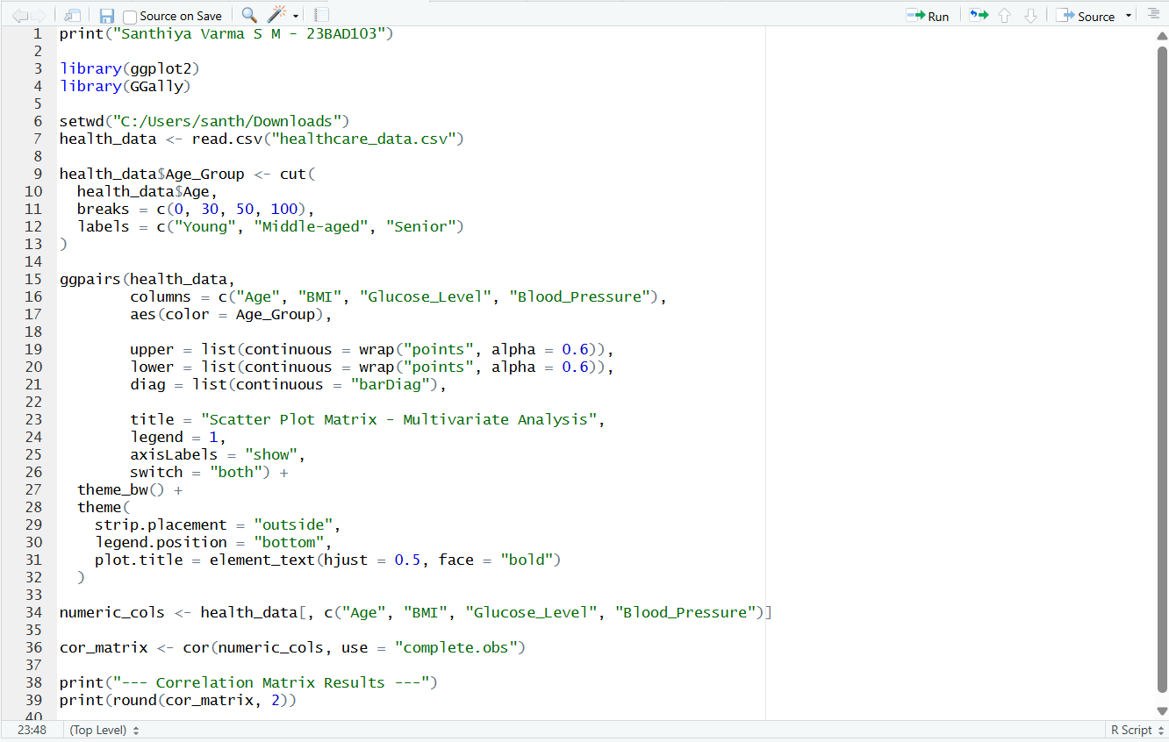

Output:

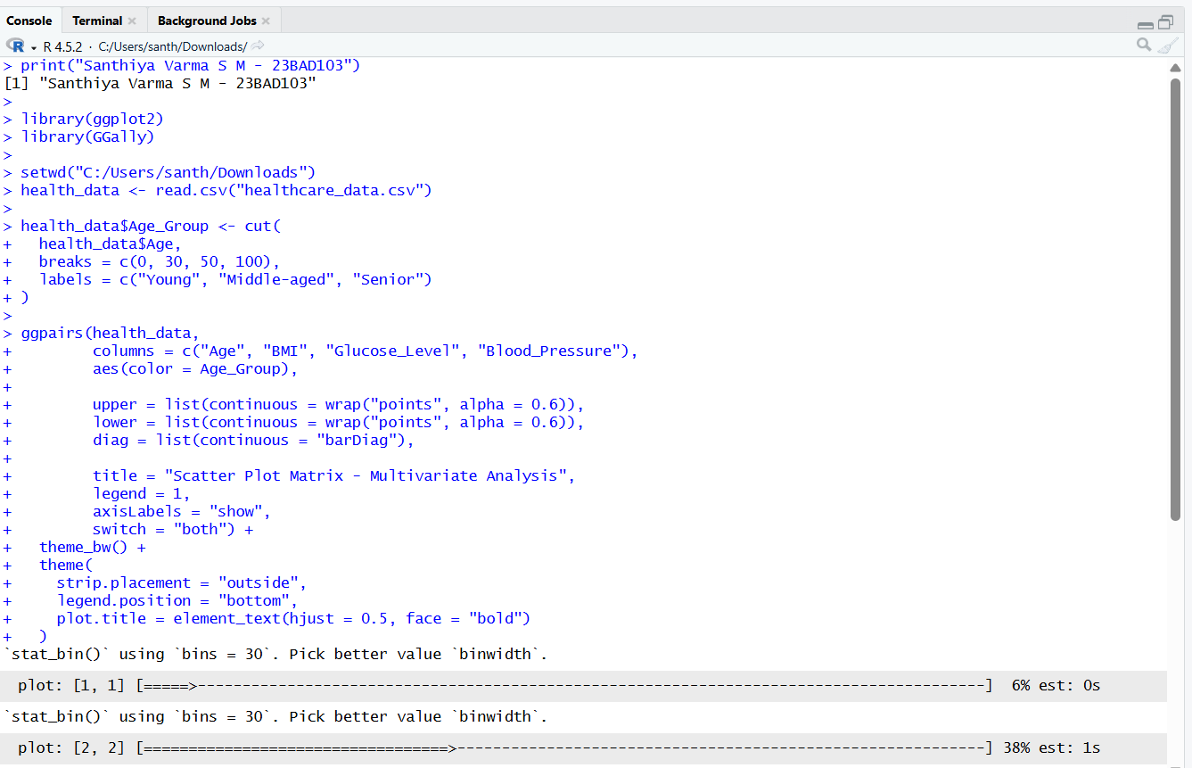
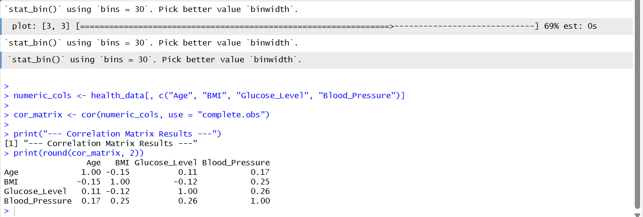

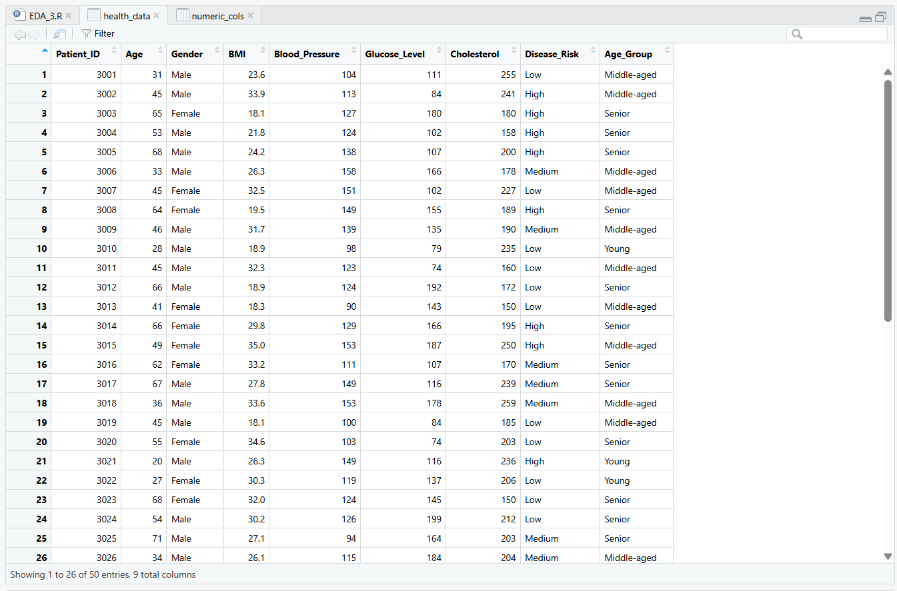
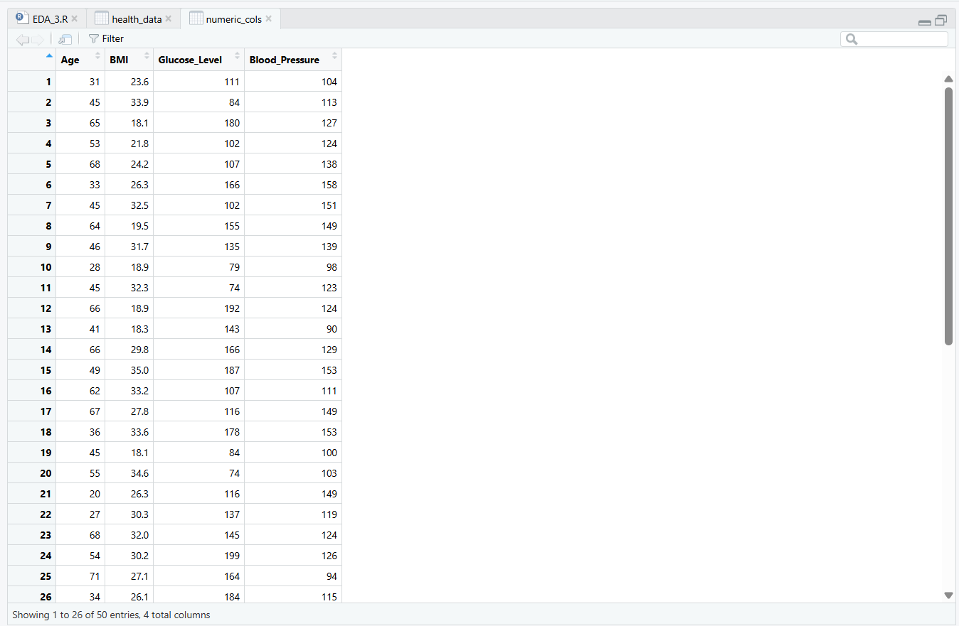
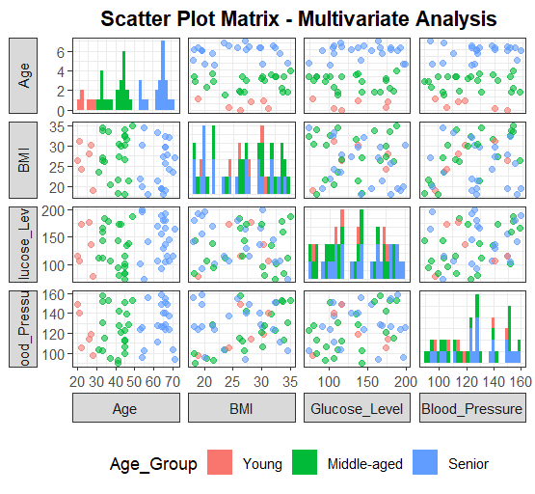

POST-LAB QUESTIONS (PROVIDE BRIEF ANSWERS TO THE FOLLOWING QUESTIONS)
- Which health parameters show strong correlation?

From the correlation matrix and scatter plot matrix, BMI and Blood Pressure show a strong positive correlation. A noticeable association is also observed between Age and Blood Pressure, indicating that cardiovascular parameters tend to vary together. Other variable pairs show weaker or moderate correlations.

- Why correlation does not imply causation in medical data?

Although correlations are observed between certain health parameters, they do not indicate a cause-and-effect relationship. Medical data is influenced by multiple biological, environmental, and lifestyle factors. Without clinical trials or controlled studies, it cannot be concluded that changes in one parameter directly cause changes in another.

- How can these patterns assist predictive healthcare AI?

The identified multivariate patterns help predictive healthcare AI models by capturing relationships among age, BMI, glucose level, and blood pressure simultaneously. This enables better risk prediction, early disease identification, and more reliable health assessments by considering multiple indicators together rather than individually.

- What visualization limitations exist for high-dimensional data?

High-dimensional data visualization becomes difficult to interpret due to overlapping data points, visual clutter, and limited display space. Scatter plot matrices may become complex as the number of variables increases, making it harder to clearly identify relationships among all parameters.

- How can dimensionality reduction improve visualization?

Dimensionality reduction techniques simplify visualization by reducing the number of variables while retaining important information. This improves clarity, minimizes clutter, and helps in identifying dominant patterns and relationships more effectively in multivariate healthcare data.

ASSESSMENT
Description | Max Marks | Marks Awarded
Pre Lab Exercise | 5
In Lab Exercise | 10
Post Lab Exercise | 5
Viva | 10
Total | 30
Faculty Signature

